City slickers dog groominG 



Matted dog policy

*Dogs that aren’t brushed at home or brought in for grooming regularly run the risk of becoming matted. In turn, this makes our job more risky when trying to remove the mats, either by brushing them out or clipping them off. Mats and knots can become quite tight and close to the skin and the risk of being cut, rashed or inflamed is then heightened.*

*In order to keep your dog in his best condition, we recommend regularly brushing at home, 6-8 weekly grooming sessions with us and realising that if you allow your dogs coat to become matted, we cannot be held responsible for any nicks or cuts that could occur whilst we are trying to improve the coat condition.*

*As we are an experienced salon, this does not happen often but it can happen especially as it can become quite painful for the dog - they can wriggle, bite or become agitated resulting in a nick or cut in sensitive areas such as armpits, groins or neck.*

*[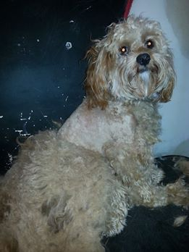](https://www.facebook.com/142616809157008/photos/pcb.575695405849144/575695392515812/?type=1)*

*Thankyou for your understanding and*

*compliance in making your*

*dog’s visit a pleasant one!*